13 April 2016
Winners and special honoured participants announced for the Odysseus II-contest regional semifinals held in Denmark 10-13 April 2016:
Sweden and United Kingdom qualifies for Odysseus Finals
It was a hard job for the jury to find the winners in the Odysseus II-contest regional semifinals. After an extra hour of evaluations a British Pioneer team and a Swedish Explorer won the prizes and a ticket to the finals.
In the Pioneers category with four team competing the winners were Team MissionRed2030 from United Kingdom consisting of students Rebecca Hayward (15) and Eleanor Ivey (16) who both attend Hockerill Anglo-European College. “We are really surprised and happy. All the groups were good so we were lucky to win”, said a smiling Eleanor Ivey.
The judges especially acknowledged that Rebecca and Eleanor made a very nice presentation and had a impressing concept for traveling to Mars and eventually living there. “Team MissionRed2030 had the most artistic submission and most innovative solution”, the jurors stated.’
In the Explorers category Daniel Nilsson (23) from Sweden won with his project Safer firefighting by using Galileo data. “I’m happy to win, but also just to participate”, said Daniel Nilsson who studies at Luleå University of Technology.
The jurors again acknowledged the concept as being very innovative and stated that Daniels project was the “Most professional presentation and most applicable project in the near future”.
“You are the future and this contest shows that we have a lot of space science talent in Europe, I’m really impressed by your projects and presentations at the semifinals here in Denmark”, said Kristian Pedersen director of DTU Space who handed over the prizes.
Although not all could win everybody were having a really good time with the four day program at the science camp. “I wish I could just stay here forever, it’s so exiting”, said Harry Woodhouse from The Royal Wootton Bassett Academy in the United Kingdom.
The accompanying teachers also felt that they could go back with new knowledge of space science and technology. “It’s been a really impressing program and the young people have meet each other and participated regardless of differences in age and countries. We should be doing much more international exchanges like this”, said teacher Guy Dinwiddy from Hockerill Anglo-European College.
Apart from the competition there were drone flying, rocket-calculations and launch, a visit to a nearby observatory and a number of speeches.
Even the Danish sky provided inputs; The ISS flew by on a clear late evening sky over the lake at Soroe where the event took place. And teacher and astrophysicist at the camp Steen Jorgensen took out his telescope a focused in so all could see Jupiter and a number of it’s impressing moons sharp and clear.
Altogether there were 13 Participants in the regional semifinals at Soroe in Denmark coming from the United Kingdom, Finland, Sweden and Denmark. Four were distributed in three groups in the Explorers category and nine were constituting four groups in the Pioneers category.
In July the winners will go to Brussels for the finals and receive their prize – a computerized telescope.
All groups were honoured for their projects:
Pioneers category:
Winners: MissionRed2030. For most artistic submission and most innovative solution
- Rebecca Hayward - United Kingdom, Hockerill Anglo-European College, Team MissionRed2030.
- Eleanor Ivey - United Kingdom, Hockerill Anglo-European College, Team MissionRed2030.
Honoured: Team: evidence for Big Bang. For most ambitious project - you have a future in astrophysics
- Tom Knighton - United Kingdom, St. Jonhs School, Team: evidence for Big Bang.
- Tom Ellis - United Kingdom, St. Jonhs School, Team: evidence for Big Bang.
Honoured: Team: Managing Resources on Mars. For Best usage of space knowledge basics
- Mike Edwards - United Kingdom, Royal Wootton Bassett Academy, Team: Managing Resources on Mars.
- Jos Jeapes - United Kingdom, Royal Wootton Bassett Academy, Team: Managing Resources on Mars.
- Harry Woodhouse - United Kingdom, Royal Wootton Bassett Academy, Team: Managing Resources on Mars.
Honoured: Team Hime/Enceladus. For most original and challenging problem
- Emil Enevoldsen - Denmark, Store Magleby Skole, Team Hime.
- Carl Vistisen - Denmark, Holbergskolen, Team Hime.
Explorers category
Winner. Project: Safer firefighting by Galileo data. For Most professional presentation and most applicable project in the near future
- Daniel Nilsson - Sweden, Luleå University of Technology, Safer Firefighting.
Honoured. Project: Lunar Base. For best usage of space knowledge basics
- Topias Zein, Finland, Aalto University, project: Lunar settlement.
Honoured. Project: ARTEMIS. For most comprehensive overview of current and future space technology
- Federico Giusto - United Kingdom, Loughborough University, team: Martian Transfer Vehicles.
- James Cooper - United Kingdom, Loughborough University, team: Martian Transfer Vehicles.
-Ends-
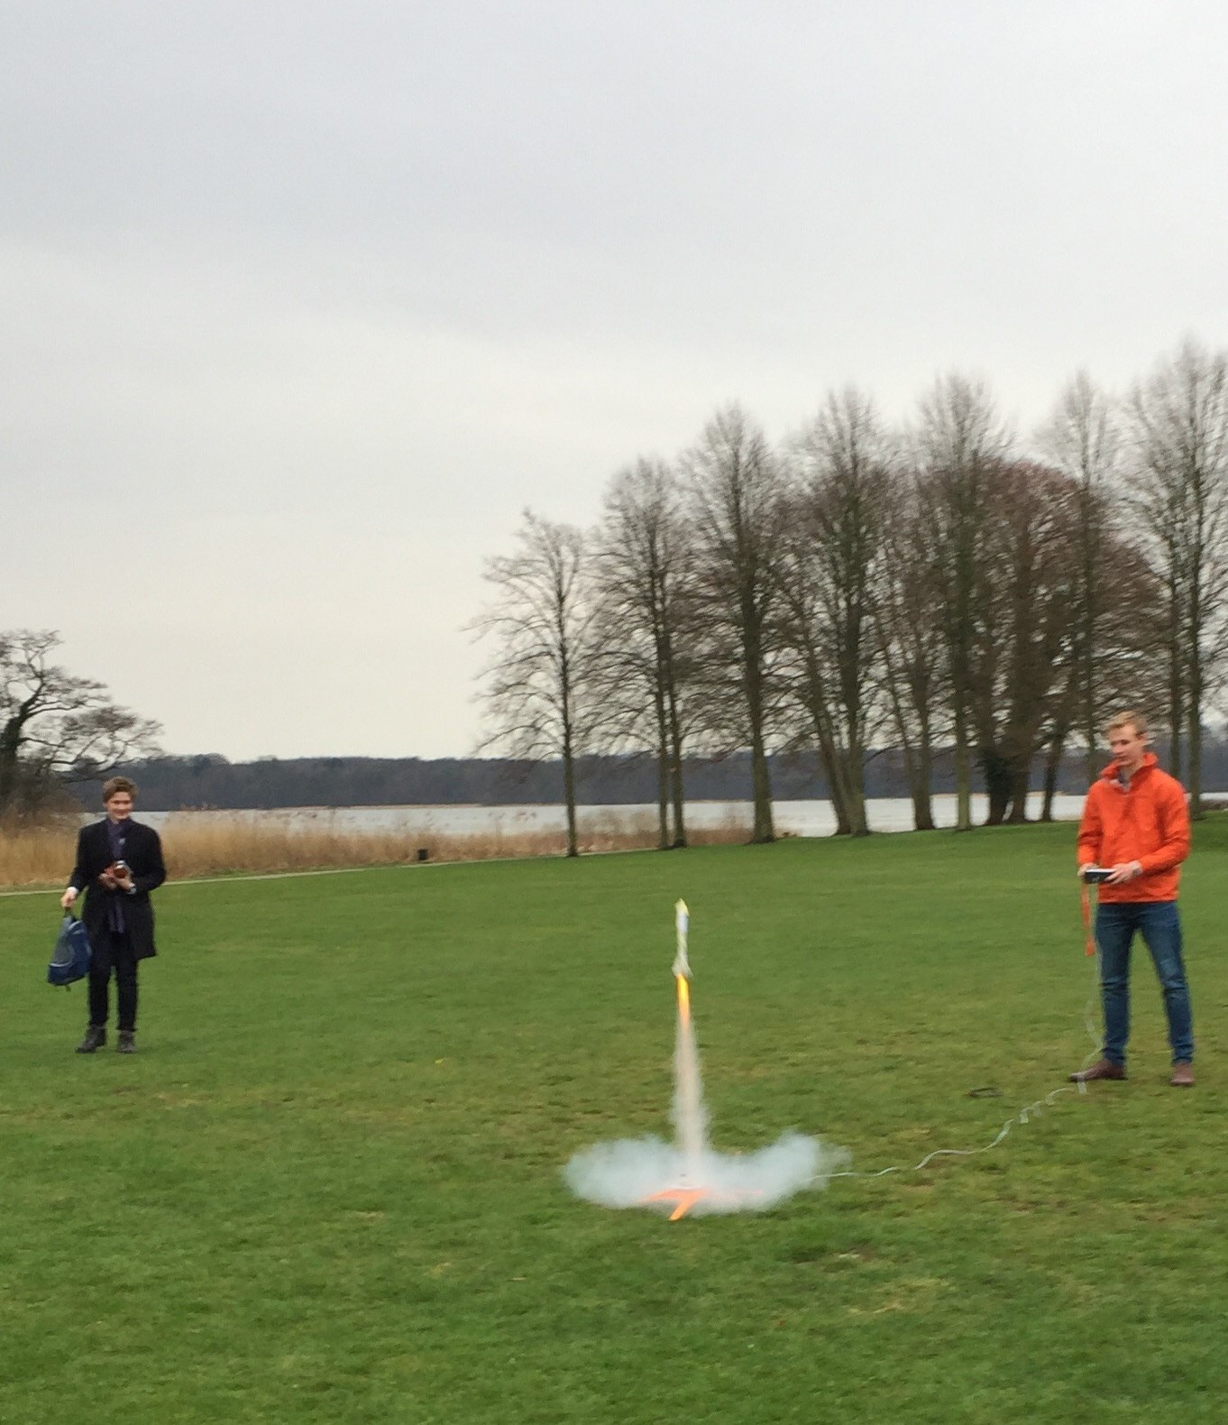
Photo 1: Rocket launch after calculations and production own individual rocket

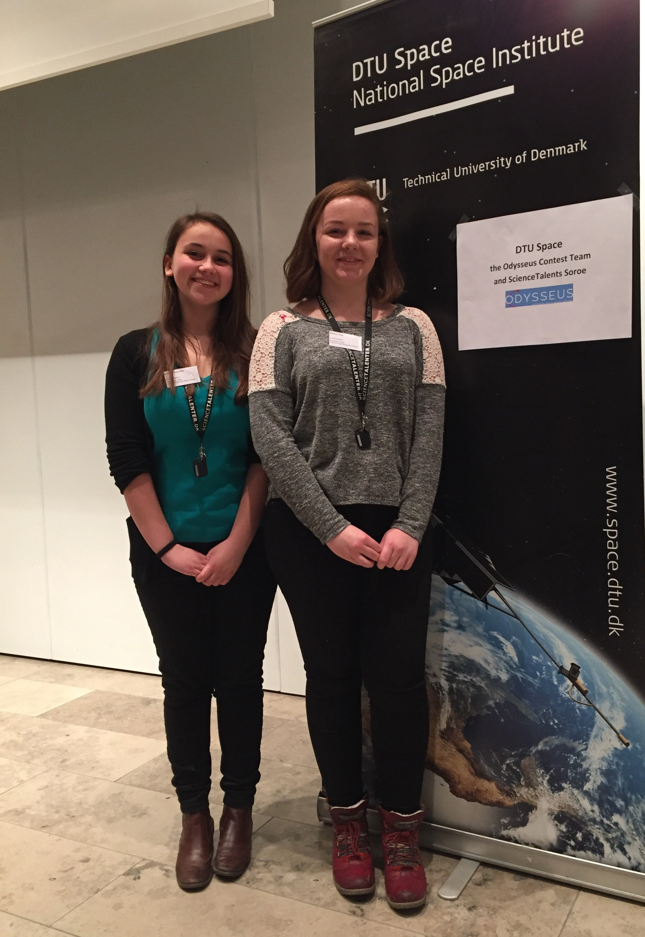
Photo 2 Rebecca Hayward (left) and Eleanor Ivey. Winners in the pioneer category
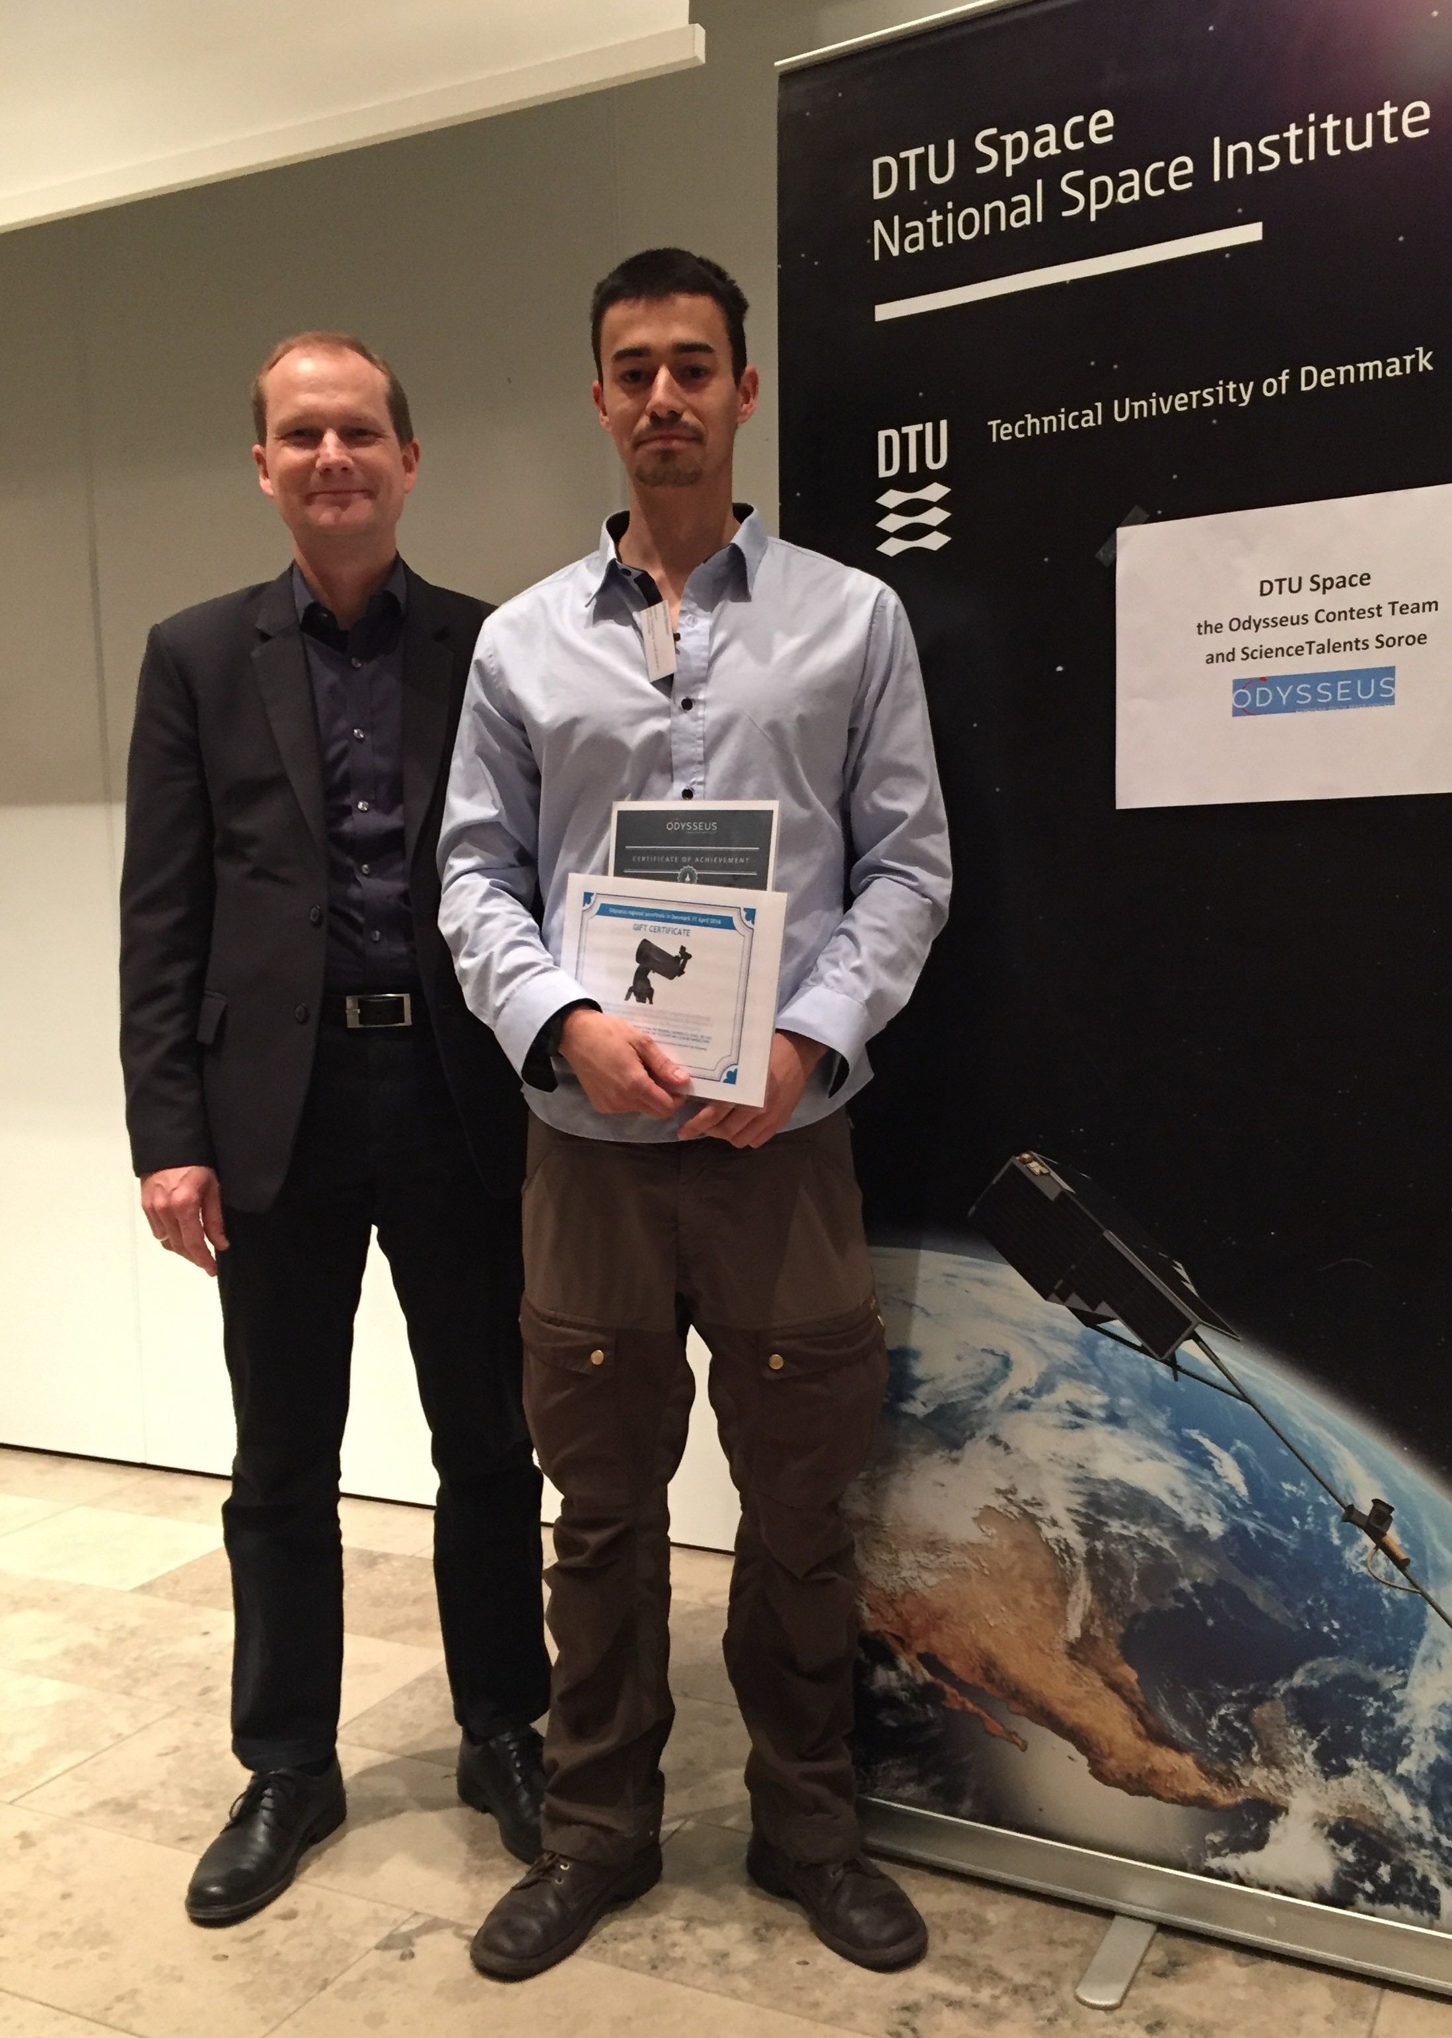
Photo 3: Daniel Nilsson (right). Winner in the Explorers category receives his prize from DTU Space director Kristian Pedersen

